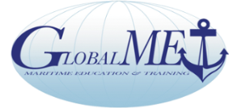

Global Maritime Education and Training Association

GlobalMET Limited: An Australian not-for-profit company - ACN 103 233 754 - established in 1996
AMC-UTAS Maritime Way, Newnham, Locked Bag 1397 Launceston Tas 7250
Chair: Capt Pradeep Chawla Anglo-Eastern Ship Management Hong Kong | Director - ExecSec: Capt Richard Teo (Australia)  Tel +61411725556 E: richsteo@gmail.com

Secretariat: Core Competency Training & Services 1070 10F Tower B1 Spaze iTech Park Gurgaon122002 India

Tel 91 124 45525 59 globalmet.secretariat@gmail.com, www.globalmet.org

The Global MET Network with NGO Observer Status at IMO

WITH COMPLIMENTS Date:

To: Chairman GlobalMET

From: ……………………………………………………………………………………………………….
Phone: ……………………………………………………………………………………………………..
Email: ……………………………………………………………………………………………………….

I/We will attend the meeting on 27 May 2020 to be held virtually.

Comments, if you wish to provide relevant information.

Official Use only:

